
Crater Lake 1 ½ hrs. from HRRC
He Restoreth Ministries, Inc

Summer 2025

Greetings! I am thankful for all that God has done this summer. As usual, the summer was very busy with online counseling, irrigation, care for Ruth, and maintenance. The retreat center has been slower than usual. I took time to contact mission organizations and talk to organizations about what we have to offer here at HRM.

Member care for missionaries

In the process of contacting mission organizations, the Lord allowed me to meet two missionary member care directors. Member care is the emphasis on working to care for the welfare of the missionary. After talking with them, I began to pray and think about how I could help them. I am working with these two directors to help enhance the member care for missionaries in their organizations. This seems to be a very promising endeavor, and I am excited. Please pray!

The following is an inspiration that has come out this time.
If I speak the local language fluently, but have not love,
I am a noisy gong or a clanging cymbal.
If I share the gospel so thousands come forward and completely understand the native culture,
and if I have all faith, so as to heal the sick or raise millions of dollars for missions and the poor, but have not love, I am nothing.
If I give away everything to go to the mission field and live in a mud hut with the poor, but have not love, I am nothing!
(Adapted from I Cor. 13)

Prayer request for HRM

- Pray for the completion of easement paperwork. We thought there had been a breakthrough and that an agreement had been worked out, but it appears to have fallen through at this point. Pray that our neighbors will change their minds and agree to the drafted easement.
- Pray for me as I continue to do counseling and encouragement, paperwork, maintenance of the property, and care for Ruth. I need His wisdom and discernment.
- Wisdom and direction for the HRM board.
- Pray about goals to enhance the apartment, build a new swing set, and possibly set up some RV spaces with water and electricity.

Thank you to those who are helping us and
praying for this ministry!

- Pray for wisdom and insight to know how to strengthen missionaries through counseling and encouragement.
- Pray for resources and strength to continue all that we are doing here!
- Pray for sensitivity to the Holy Spirit’s direction to determine how to precede to stay in the center of His will.
- Pray for missionaries around the world to be encouraged to continue carrying out the Great Commission.

HRM Prayer Requests
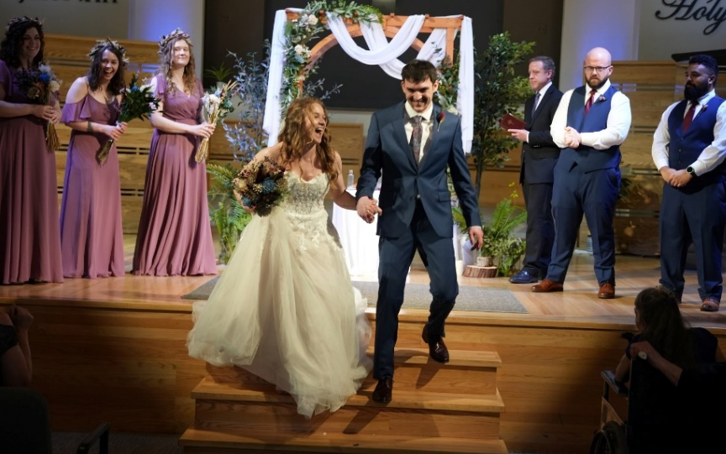
Family Prayer Requests

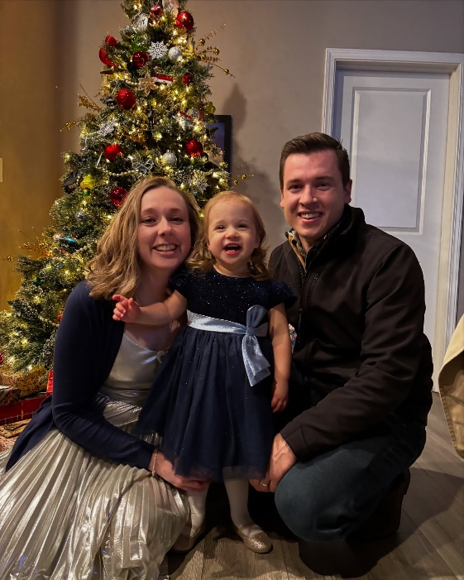
- Rebekah and Zach’s wedding was amazing!! They are living in Washington and have been continuing the jobs they had before. They are expecting! Also, Zach has just finished his BA!
- Please pray for Ruth! Eating and talking have become more difficult for her. Pray for her healing and wisdom to know what we can do to help,
- Pray for Timothy and Ashley and Amelia. They are very busy. Pray for Ashley as she considers staying home to homeschool Amelia.
- Pray for Hannah as she continues to teach full-time in the extended care program for Grace Christian School. Pray for her as she looks for another job and internship to finish her master’s degree.
- Pray for Elisabeth. She is now working 3 jobs. In addition to the jewelry repair job in the mall and her job selling jewelry, she now has a job at a dental lab. She needs wisdom to know which jobs to continue.
Love, Brent and Ruth, for the family and HRM

