
Cater Lake 1 ½ hrs. from HRRC
He Restoreth Ministries, Inc

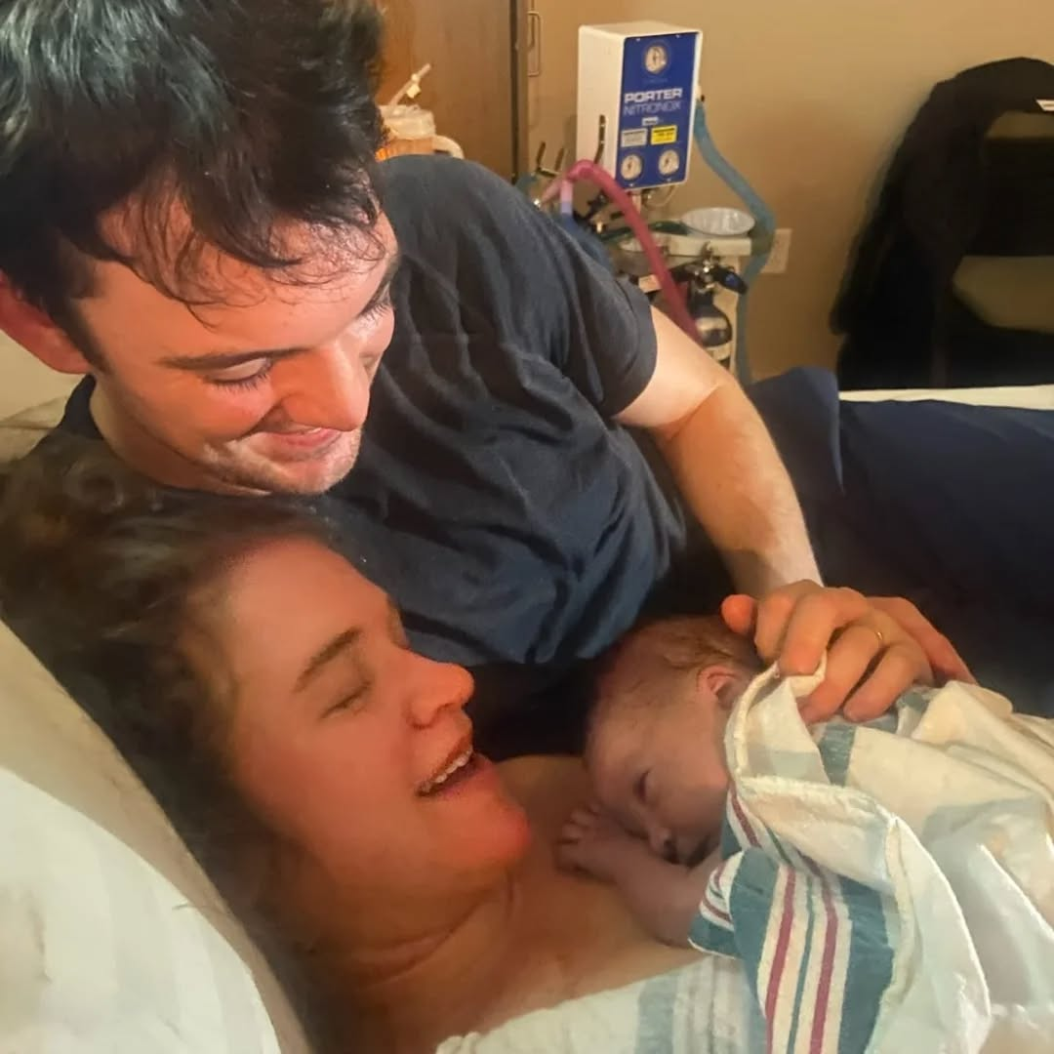
Winter 2025-26
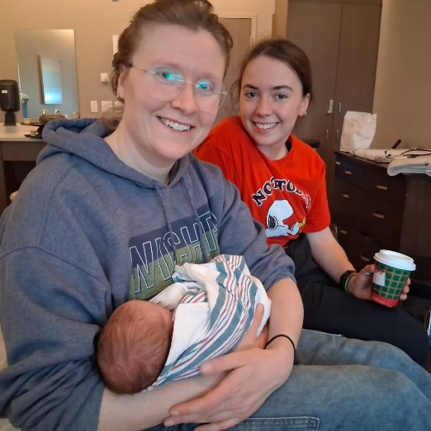
Hope everyone had a great Christmas and New Years break!
Ours was especially wonderful because of the arrival of
Eiley Rose Miller
to Rebekah and Zach. She was born on December 20th, 2025; 7 lbs. 4.9 oz.in Port Orchard WA.
Hannah and Elisabeth traveled up to Washington to help on Dec. 20 for several days.
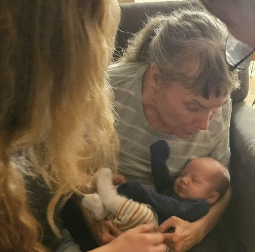
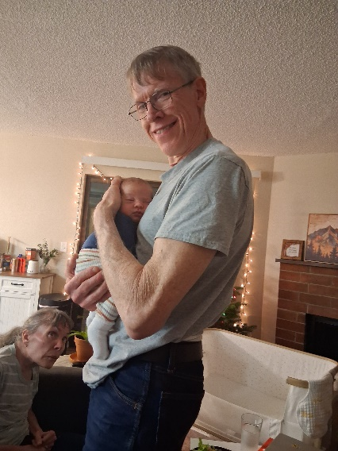
Then Ruth and I drove up January 6th to visit.

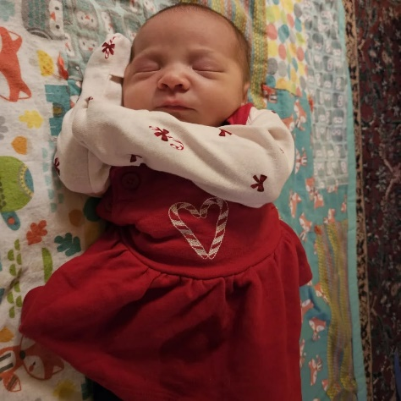
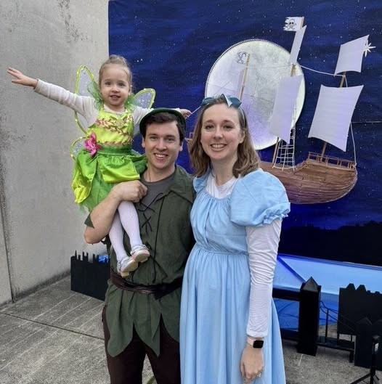

Help us get the word out! We offer free counseling, debriefing, retreats* for missionaries.
*Missionaries bring and fix their own food and pay for heating pellets (winter).

- Praise the Lord! We have already been able to minister to one family this year at the retreat center. Pray for more to come.

- Pray for missionaries struggling with burnout.

- Pray for resources and strength to continue all that we are doing here! Also, pray for resources to make improvements on the property and apartment.

- Praise the Lord for friends, Bible study groups, church groups, mentors, and mutual discipleship groups that keep us encouraged!

Thank you to those who are helping us and
praying for this ministry!

HRM Report

Family Prayer Requests

- Please pray for Ruth! Pray for her healing and comfort. Pray that God would encourage her as she struggles this sickness that confines her to a chair all day!
- Pray for Timothy, Ashley, and Amelia. Pray for Ashley as she plans to stay home to homeschool Amelia.
- Pray for Hannah. Pray for wisdom as she considers what to do for her internship and her work situation.
- Pray for Elisabeth. She is working hard and doing well.
Love, Brent, Ruth, and for the family and HRM

